[Document title]

[Document subtitle]

[Company name]  [Company address]

1. **Assessment Requirements**

Load balancing alludes to effectively conveying approaching organization traffic across a gathering of backend servers, otherwise called a server ranch or server pool.

Current high‑traffic sites should serve many thousands, if not millions, of simultaneous solicitations from clients or clients and return the right text, pictures, video, or application information, all in a quick and quickly and solidlytively scale to meet these high volumes, present-day registering best practices, by and large, requires adding more servers.

**Application Load Balancer parts**

A heap balancer fills in as the single resource for clients. The heap balancer disperses approaching application traffic across different targets, for example, on EC2 occasions, in various Availability Zones. This expands the accessibility of your application. You add at least one audience member to your heap balancer.

An audience checks for association demands from clients, utilizing the convention and port that you design. The standards that you characterize for an audience decide how the heap balancer courses solicitation to its enlisted targets. Each standard comprises a need, at least one activity, and at least one circumstance. At the point when the circumstances for a standard are met, then, at that point, its activities are performed. You should characterize a default rule for every audience, and you can alternatively characterize extra principles.

Each target bunch courses solicitations at least one enlisted target, for example, EC2 occurrences, utilizing the convention and port number that you indicate. You can enroll an objective with various objective gatherings. You can design well-being minds for each target bunch premise. Wellbeing checks are performed on all objectives enlisted to an objective gathering that is determined in an audience rule for your heap balancer.

The accompanying outline delineates the fundamental parts. Notice that every audience contains a default rule, and one audience contains one more decide that courses solicitations to an alternate objective gathering. One objective is enlisted with two objective gatherings.

**• You must discuss the challenges that**

The issue with load adjusting is the point at which various servers are available, all solicitations and data during a client's meeting are put away in various backend servers. This will upset the client's meeting. Preferably, when a client's meeting is going on, all solicitations and data during a specific meeting are put away in the equivalent backend server to make the client's meeting more productive and less complex. This can be accomplished by doing tenacity (tacky meetings), where the heap balancer is told to speak with the equivalent backend server when a client's meeting is occurring, regardless of whether different servers are available.

Indeed, sending a load balancer can be useful on the off chance that you can handle the issues that might accompany it. A careful assessment of IT climate and business needs as well as direction from the master will assist you with procuring the greatest advantages of the arrangement. CTI Group will help you manage more responsibilities with less concern.

**encountered and solved for your project**

**Problems were faced :**

**1. Execution Degradation:**

It might prompt execution debasement as burden balancers dole out the same or foreordained loads to different assets and in this manner, it can bring about terrible showing concerning rate and cost. Hence, it is the need to have powerful burden balancers that equilibrium load is contingent on the kind of assets.

**2. Load Level Comparison:**

Load dispersion ought to be done in light of the premise of burden level correlation of various servers. Consequently, an entire framework should be set ready for gathering and keeping up with the server's status information.

**3. Load Estimation:**

It is impossible to decide or anticipate the heap or the all-out number of cycles on a hub since the interest for process assets varies rapidly.

**4. Execution Indices:**

The exhibition lists of the framework shouldn't debase anything over a specific point. Load balancers ought to give solidness. So, they need to ensure that during outrageous occasions like when the number of solicitations from the server increments radically.

**5. Measure of Information Exchanged among Nodes:**

As we know that fixing network issues is very troublesome. What's more, acquainting a heap balancer with the image adds to the trouble. It very well may be difficult to tell whether the heap balancer is just disposing of bundles, changing parcels, or expanding delay.

**6. Effortlessness:**

The calculation of the heap balancer ought to be less complex, it ought not to be refined or of high time intricacy. The more the framework gets muddled the more inertness increments in this manner expanding the reaction season of the server. Hence e, the disseminated framework's general efficiency will be hurt by a complex calculation.

**7. Homogeneous hubs:**

The prerequisite assumptions from a framework change occasionally. Consequently, we can't go for homogeneous hubs i.e. the hubs which are made to do a particular sort of errand. Subsequently, creating a productive burden by adjusting answers for different conditions/hubs is a troublesome errand.

**Along with the benefits of the load balancer, several challenges remain. For example, when you implement a load balancer, the number of Transmission Control Protocol (TCP) connections and the number of servers must be equal, so it can distribute the workload evenly. This balance is sometimes impossible because when a server malfunction, a “long-lived” TCP will dump all the workload to the working server, even after the malfunction is corrected. This issue, however, can be tackled by making the connections not long-lived. Allowing connections to live for no longer than 10 minutes, for instance, means that about 10 minutes after you bring the second server online, the load should be back to being balanced.**

**Dynamic Configuration of Server Groups**

Numerous fast‑changing applications require new servers to be added or brought down consistently. This is normal in conditions, for example, the Amazon Web Services (AWS) Elastic Compute Cloud (EC2), which empowers clients to pay just for the registering limit they use, while simultaneously guaranteeing that limit increases accordingly to traffic spikes. In such conditions, it significantly helps if the heap balancer can powerfully add or eliminate servers from the gathering without hindering existing associations.

**Equipment versus Programming Load Balancing**

Load balancers regularly come in two flavors: hardware‑based and software‑based. Merchants of hardware‑based arrangements load restrictive programming onto the machine they give, which frequently utilizes processors. To adapt to expanding traffic at your site, you need to purchase more or greater machines from the seller. Programming arrangements by and large sudden spike in demand for product equipment, making them more affordable and more adaptable. You can introduce your preferred product on the equipment or in cloud conditions like AWS EC2.

1. **Assessment Scenario/Problem**

**Load Balancing Techniques**

Load Balancing Techniques

Various indistinct workers are intended to provide comparable styles of help or applications. They are intended to utilize an identical Internet area call, but everyone has a thrilling IP to adapt to. The load balancer has a summary of all exhilarating IP addresses related to placing names on the Internet. The factor while assembly needs are mentioned at the employee associated with the Internet place call, they're heedlessly or solely allowed. For example, the essential call for receiving the IP adapt to of representative 1, the second one needs the IP adapt to of worker 2, and sales that the doorway call for on representative 1 has been determined to all workers for a cycle to restart.

**Robin Round**

This is the very best approach for load changing representatives, or for giving truthful edition to trivial disappointment. Various unclear representatives are intended to provide it ought to be comparable styles of help or applications. All are intended to utilize a similar Internet area call, but everyone has an interesting IP to adapt to. The pile balancer has an overview of all of the outstanding IP tends to which can be associated with the Internet area call. At the factory, while needs for conferences at the employees associated with the Internet place call are gotten, they're distributed in a sporadic, or turning successive way. For example, the essential sales get the IP adapt to of worker 1, the accompanying requesting gets the IP adapt to of representative 2, and so on, with needs starting once more at representative 1 while all employees had been consigned a frontal for the term of a cycle.

Your methodology is a static burden adjusting by diverting the calls to another server. All following calls might utilize this other server or are shipped off the heap balancer again for divert.

**Source Address Hash Method**

Source address hashing is to get the IP address esteem got to by the client, compute a worth by hash capability, and utilize this worth to modularize the size of the server list. The outcome is the chronic number of the server to be gotten to. The code execution of the source address hashing calculation is as per the following:

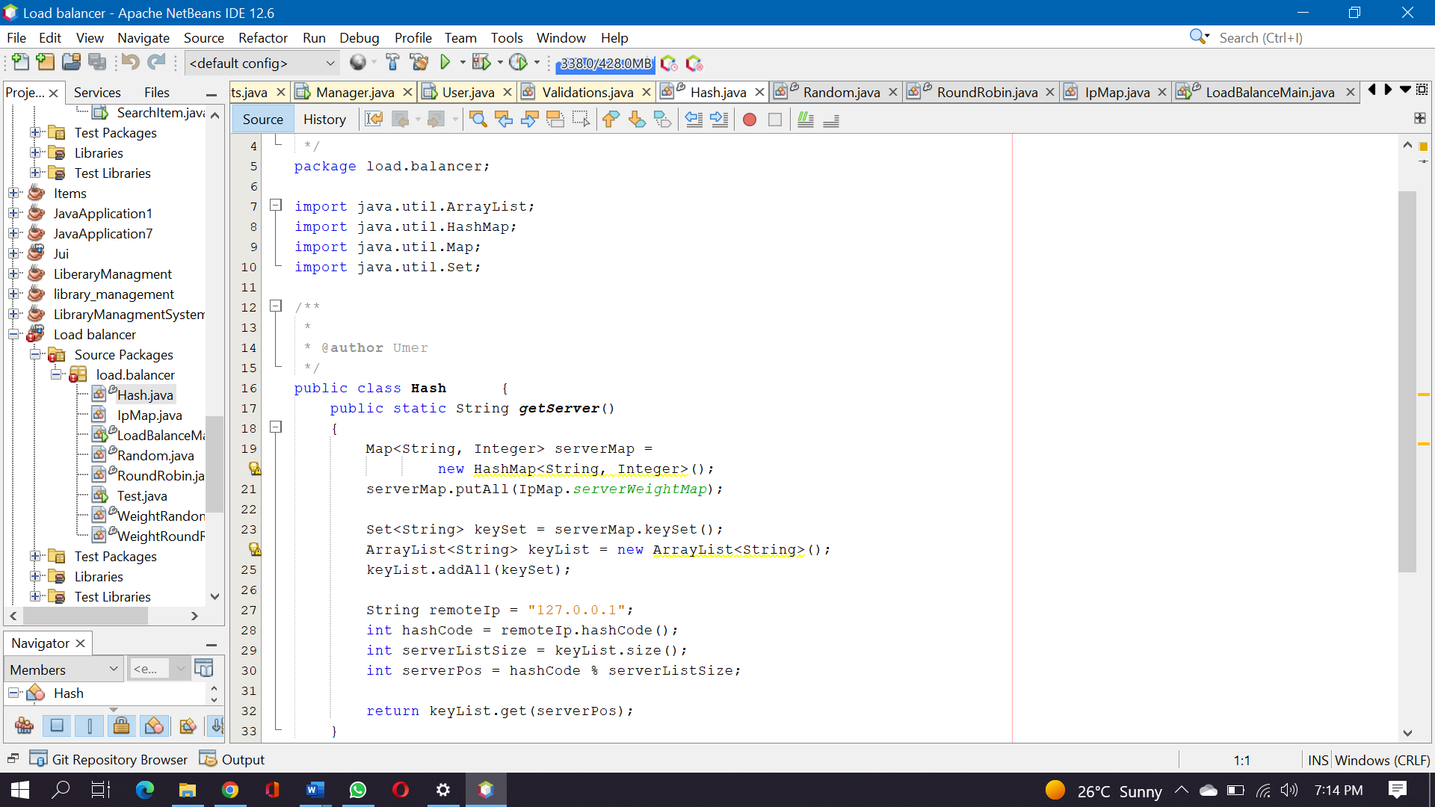

**Weight ed Random) technique**

Like the weighted surveying technique, the weighted arbitrary strategy assigns various loads as indicated by the different setup and heap of the back-end server. The thing that matters is that it haphazardly chooses servers by weight, not by request. The code execution of the weighted arbitrary strategy is as per the following:

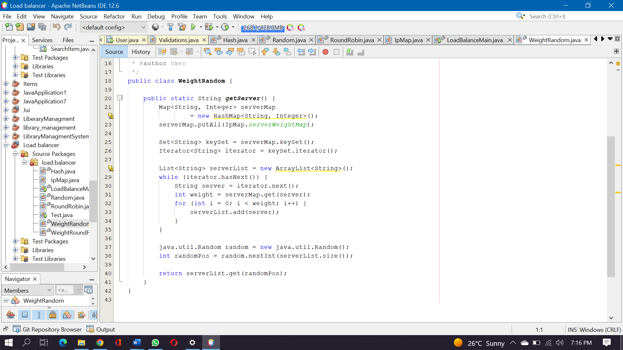

The initial not many strategies are attempting to accomplish a decent conveyance of the number of solicitations from administration customers. ObIts great to do such. They can disperse the responsibility similarly for various servers in the back end and augment the use of servers. Be that as it may, is this valid? Practically speaking, could the equilibrium of solicitations at any point truly address the equilibrium of burden? This is an inquiry worth pondering.

The above issue, in another way, is to notice the heap of the framework according to the point of view of the back-end server, as opposed to the originator of the solicitation. The base number of associations technique has a place in this class.

The base number of associations calculation is adaptable and keen. Since the design of the back-end server is unique, the handling of solicitations is quick or slow. As per the ongoing association circumstance of the back-end server, it progressively chooses the server with the most un-number of build-up associations with the process the ongoing solicitations, to further develop the use proficiency of the back-end server however much as could be expected and disperse the heap to the server sensibly. Each machine. Due to the outline and view of the base number of associations, the plan and execution of the insignificant number of associations are monotonous, so we won't specify its execution here.

**Weight polling Round Robin method**

Various servers might have different machine setups and heaps of the ongoing framework, so their compressive limit is additionally unique. The machines with a high arrangement and low burden are given higher loads to deal with additional solicitations, while the machines with low design and high burden are given lower loads to lessen their framework loads. The weighted surveying strategy can manage this issue well and allot the solicitation request to the back end as indicated by the weight. The code execution of the weighted surveying technique is generally as follows:

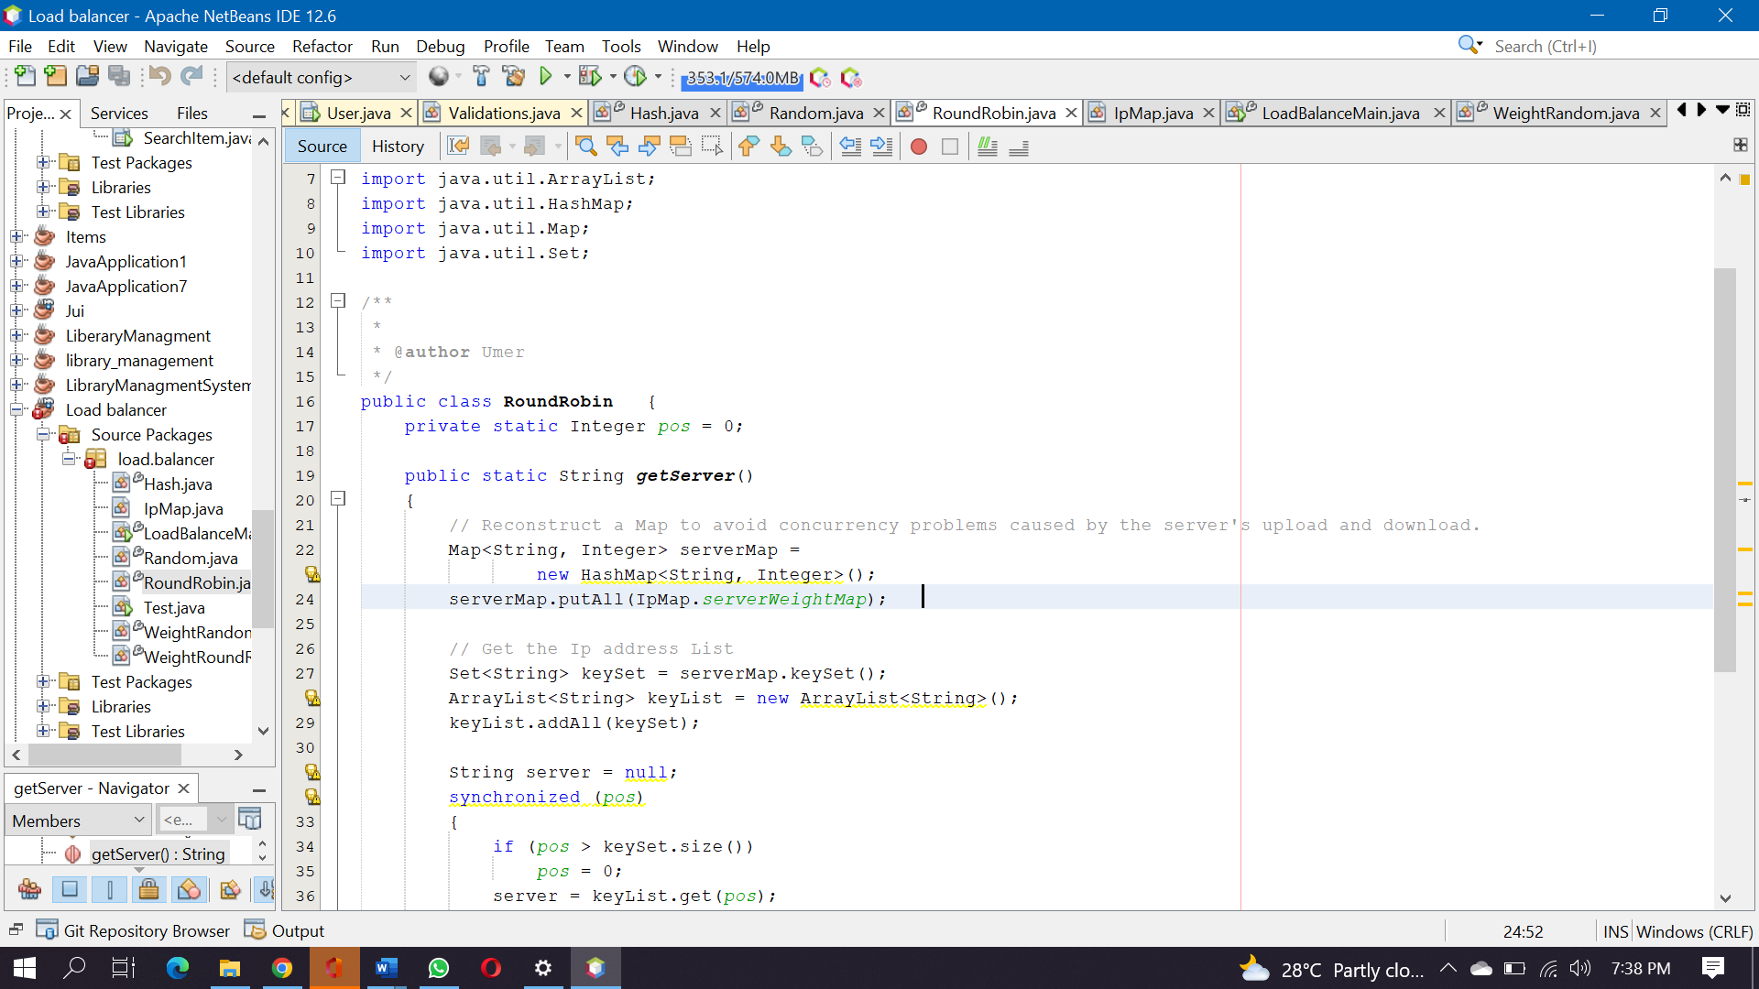

Like surveying strategy, just a weight computation code is added before the server address is gotten. As indicated by the weight, the location is more than once added to the server address list. The bigger the weight, the more demands the server acquires per round.

**Weight ed surveying Round Robin technique**

Various servers might have different machine designs and heaps of the ongoing framework, so their compressive limit is likewise unique. The machines with a high arrangement and low burden are given higher loads to deal with additional solicitations, while the machines with low setup and high burden are given lower loads to decrease their framework loads. The weighted surveying strategy can manage this issue well and dole out the solicitation request to the back end as per the weight. The code execution of the weighted surveying strategy is generally as follows:

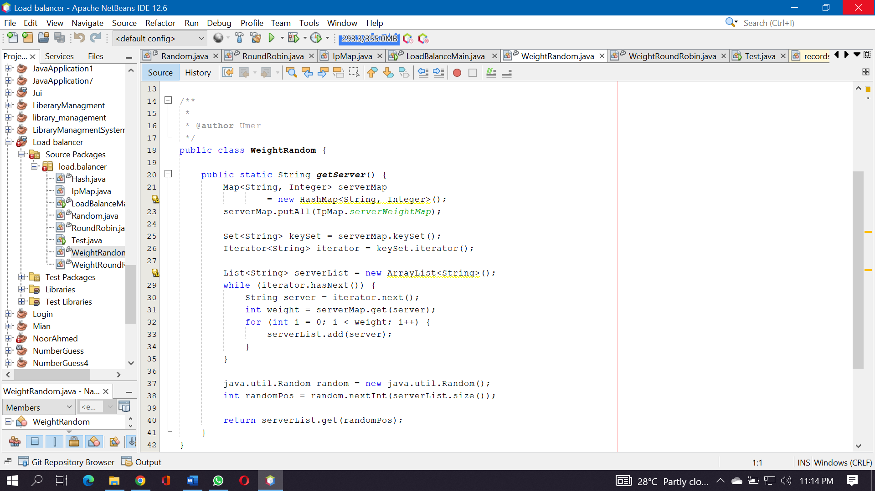

Like surveying technique, just a weight computation code is added before the server address is gotten. As indicated by the weight, the location is more than once added to the server address list. The bigger the weight, the more demands the server gets per round.

**Random method**

Through the framework’s irregular capability, one of the servers is chosen arbitrarily as indicated by the size of the back-end server list for access. From the hypothesis of likelihood and measurements, we can know that with the increment of call volume, its real impact is increasingly near the normal appropriation of traffic to each back-end server than the impact of surveying.

The code execution of the arbitrary strategy is generally as follows:

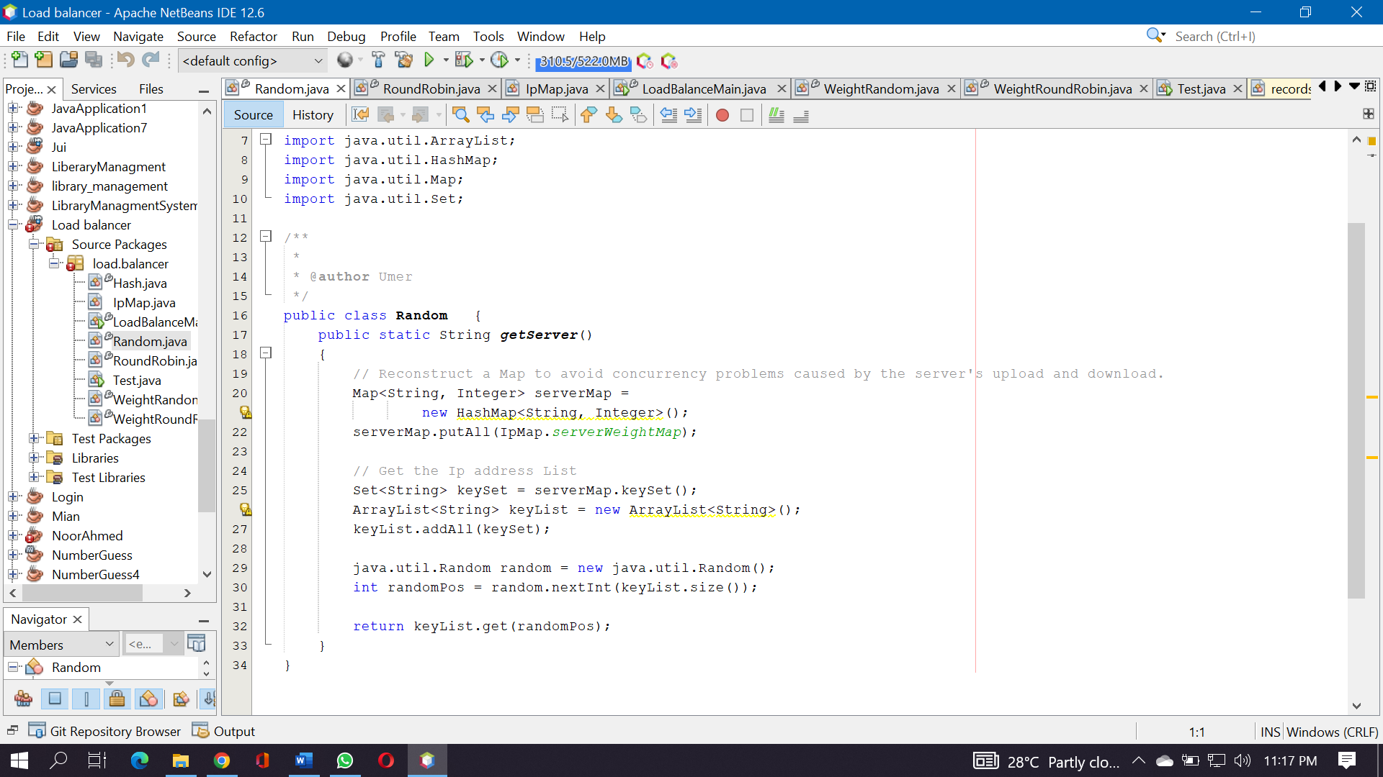

The entire code thought is predictable with surveying strategy. To start with, reconstruct serverMap, and afterward get the rundown of servers. At the point when the server is chosen, Random's nextInt technique takes an irregular worth in the scope of 0-keyList. size () to get an irregular server address from the rundown of servers for return. Considering the hypothesis of likelihood and measurements, the more noteworthy the throughput, the nearer the impact of irregular calculation is to that of surveying calculation.